**“Experiment 8”**

Student Name: **SUMIT KUMAR** UID: **20BCS8226**

Branch: **CSE** Section/Group: **808-A**

Semester: **5** Date of Submission: **06-11-22**

Subject Name: **PBLJ Lab** Subject Code: **20CSP-321**

**Aim:**

Write a Program to Program to Check if a Given String is Palindrome.

**Minimum Hardware Requirements:**

* 2 GHz CPU or 1 virtual CPU in virtualized environments.
* 1 GB of RAM.
* 4 GB of storage.

**Minimum Software Requirements:**

|  |  |
| --- | --- |
| **Software** | **Version** |
| * OS | * Mac OS 10.15, HP-UX 11i V3, AIX 7.2, Windows Server 2019, Windows 10, Solaris 11.3, Red Hat Enterprise Linux 8.1, Ubuntu Server 20.04 |
| * JDK | * JDK 1.8.0, JDK 11, Ellipse IDE, Net, NetBeans 8.2 |

**Source Code:**

// Save: PalindromeString

import java.util.Scanner;

class PalindromeString

{

public static void main(String args[])

{

String str, rev = "";

Scanner sc = new Scanner(System.in);

System.out.println("Enter a string:");

str = sc.nextLine();

int length = str.length();

for ( int i = length - 1; i >= 0; i-- )

rev = rev + str.charAt(i);

if (str.equals(rev))

System.out.println(str+" is a palindrome");

else

System.out.println(str+" is not a palindrome");

}

}

**Output:**

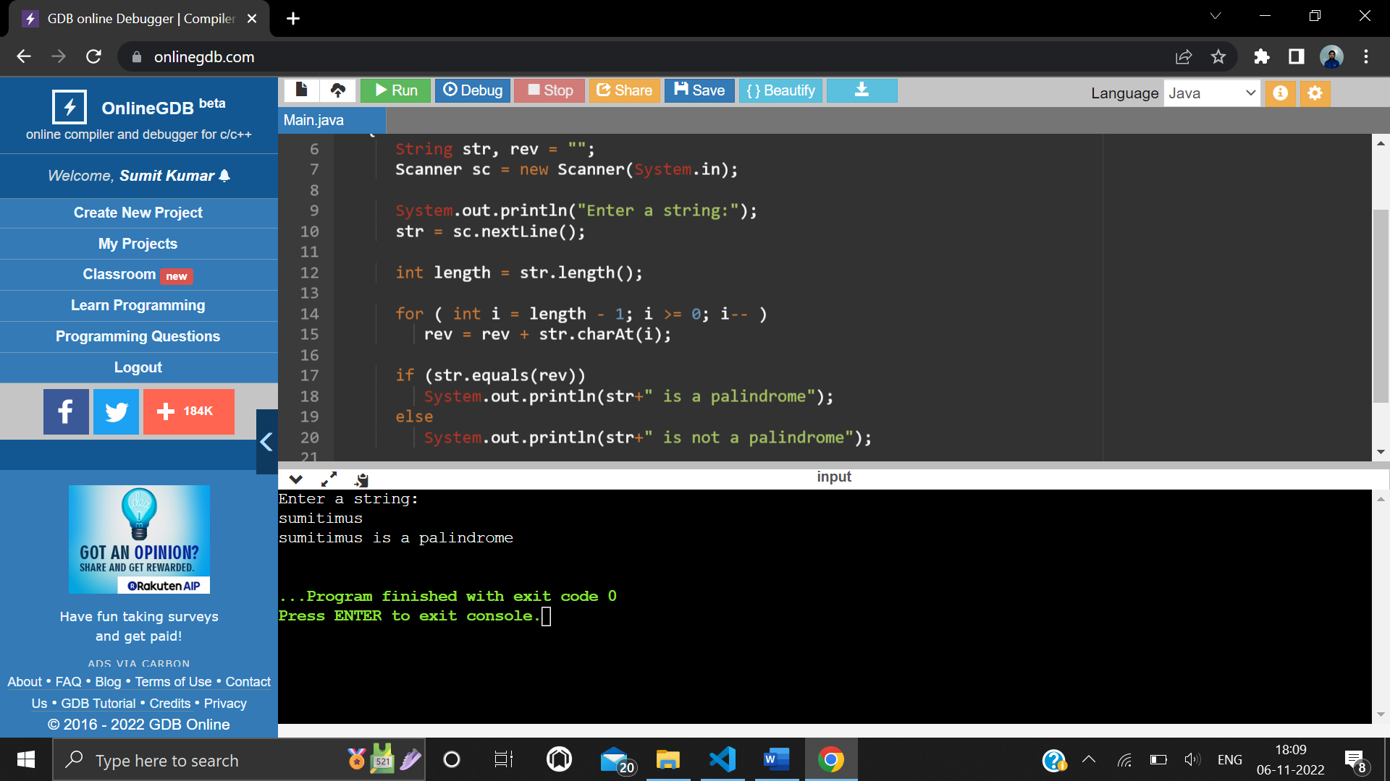

Output when a palindrome string is entered

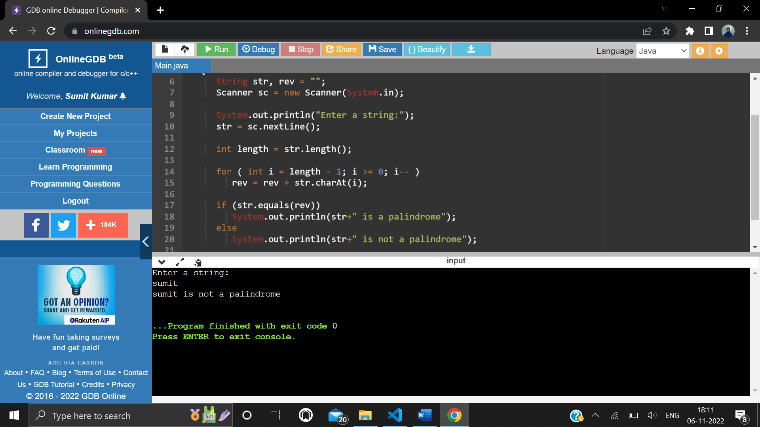

Output when a non-palindrome string is entered